Thực hành kiến trúc máy tính tuần 10

GIảng viên : Lê Bá Vui

Sinh viên : Hoàng Đức Anh 20176688

Assignment 1

Code:

.eqv SEVENSEG_LEFT 0xFFFF0010 # Dia chi cua den led 7 doan trai.

# Bit 0 = doan a;

# Bit 1 = doan b; ...

# Bit 7 = dau .

.eqv SEVENSEG_RIGHT 0xFFFF0011 # Dia chi cua den led 7 doan phai

.text

main:

li $a0, 0x7F # set value for segments

jal SHOW_7SEG_LEFT # show

li $a0, 0x7F # set value for segments

jal SHOW_7SEG_RIGHT # show

exit: li $v0, 10

syscall

endmain:

#---------------------------------------------------------------

# Function SHOW_7SEG_LEFT : turn on/off the 7seg

# param[in] $a0 value to shown

# remark $t0 changed

#---------------------------------------------------------------

SHOW_7SEG_LEFT: li $t0, SEVENSEG_LEFT # assign port's address

sb $a0, 0($t0) # assign new value

jr $ra

#---------------------------------------------------------------

# Function SHOW_7SEG_RIGHT : turn on/off the 7seg

# param[in] $a0 value to shown

# remark $t0 changed

#---------------------------------------------------------------

SHOW_7SEG_RIGHT: li $t0, SEVENSEG_RIGHT # assign port's address

sb $a0, 0($t0) # assign new value

jr $ra

Kết quả:

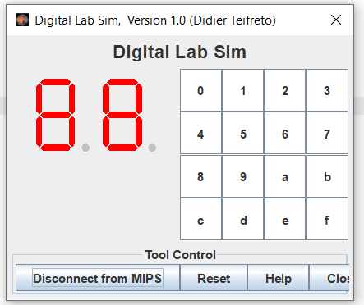

Assignment 2:

Code:

.eqv MONITOR_SCREEN 0x10010000

.eqv RED 0x00FF0000

.eqv GREEN 0x0000FF00

.eqv BLUE 0x000000FF

.eqv WHITE 0x00FFFFFF

.eqv YELLOW 0x00FFFF00

.text

li $k0, MONITOR_SCREEN

li $t0, RED

sw $t0, 0($k0)

li $t0, GREEN

sw $t0, 4($k0)

li $t0, YELLOW

sw $t0, 8($k0)

li $t0, BLUE

sw $t0, 12($k0)

li $t0, BLUE

sw $t0, 16($k0)

li $t0, YELLOW

sw $t0, 20($k0)

li $t0, GREEN

sw $t0, 24($k0)

li $t0, RED

sw $t0, 28($k0)

li $t0, WHITE

sw $t0, 32($k0)

li $t0, WHITE

sw $t0, 60($k0)

li $t0, WHITE

sw $t0, 68($k0)

li $t0, RED

sw $t0, 76($k0)

li $t0, RED

sw $t0, 80($k0)

li $t0, WHITE

sw $t0, 88($k0)

li $t0, WHITE

sw $t0, 104($k0)

li $t0, WHITE

sw $t0, 116($k0)

li $t0, RED

sw $t0, 140($k0)

li $t0, RED

sw $t0, 144($k0)

Kết quả:

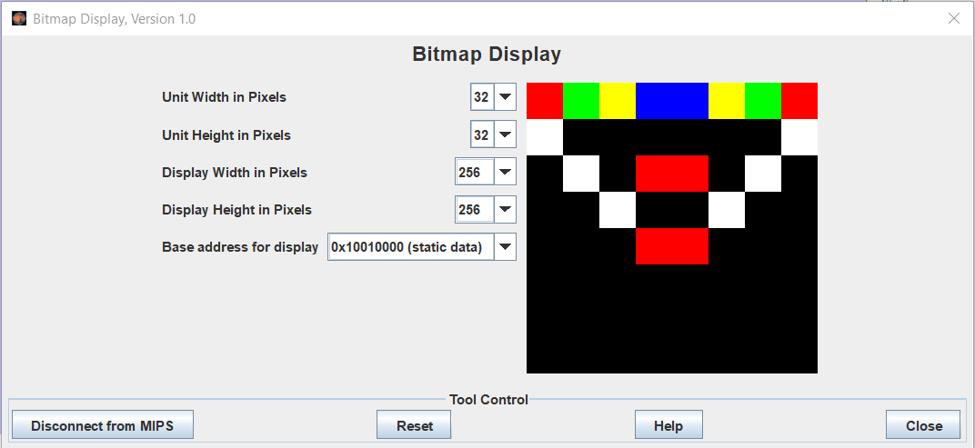

Assignment 3

Code:

.eqv HEADING 0xffff8010 # Integer: An angle between 0 and 359

# 0 : North (up)

# 90: East (right)

# 180: South (down)

# 270: West (left)

.eqv MOVING 0xffff8050 # Boolean: whether or not to move

.eqv LEAVETRACK 0xffff8020 # Boolean (0 or non-0):

# whether or not to leave a track

.eqv WHEREX 0xffff8030 # Integer: Current x-location of MarsBot

.eqv WHEREY 0xffff8040 # Integer: Current y-location of MarsBot

.text

main:

jal TRACK # draw track line

addi $a0, $zero, 90 # Marsbot rotates 90* and start

jal ROTATE

jal GO

goASKEW:

addi $a0, $zero, 120 # Marsbot rotates 120*

jal ROTATE

sleep4: addi $v0,$zero,32 # Keep running by sleeping in 2000 ms

li $a0,10000

syscall

jal UNTRACK # keep old track

jal TRACK # and draw new track line

goASKEW1: addi $a0, $zero, 240 # Marsbot rotates 120*

jal ROTATE

sleep5: addi $v0,$zero,32 # Keep running by sleeping in 2000 ms

li $a0,10000

syscall

jal UNTRACK # keep old track

jal TRACK # and draw new track line

goASKEW2:

addi $a0, $zero, 0 # Marsbot rotates 120*

jal ROTATE

sleep6: addi $v0,$zero,32 # Keep running by sleeping in 2000 ms

li $a0,10000

syscall

jal UNTRACK # keep old track

jal TRACK # and draw new track line

end_main:

#-----------------------------------------------------------

# GO procedure, to start running# param[in] none

#-----------------------------------------------------------

GO:

li $at, MOVING # change MOVING port

addi $k0, $zero,1 # to logic 1,

sb $k0, 0($at) # to start running

jr $ra

#-----------------------------------------------------------

# STOP procedure, to stop running

# param[in] none

#-----------------------------------------------------------

STOP:

li $at, MOVING # change MOVING port to 0

sb $zero, 0($at) # to stop

jr $ra

#-----------------------------------------------------------

# TRACK procedure, to start drawing line

# param[in] none

#-----------------------------------------------------------

TRACK:

li $at, LEAVETRACK # change LEAVETRACK port

addi $k0, $zero,1 # to logic 1,

sb $k0, 0($at) # to start tracking

jr $ra

#-----------------------------------------------------------

# UNTRACK procedure, to stop drawing line

# param[in] none

#-----------------------------------------------------------

UNTRACK:

li $at, LEAVETRACK # change LEAVETRACK port to 0

sb $zero, 0($at) # to stop drawing tail

jr $ra

#-----------------------------------------------------------

# ROTATE procedure, to rotate the robot

# param[in] $a0, An angle between 0 and 359# 0 : North (up)

# 90: East (right)

# 180: South (down)

# 270: West (left)

#-----------------------------------------------------------

ROTATE:

li $at, HEADING # change HEADING port

sw $a0, 0($at) # to rotate robot

jr $ra

Kết quả

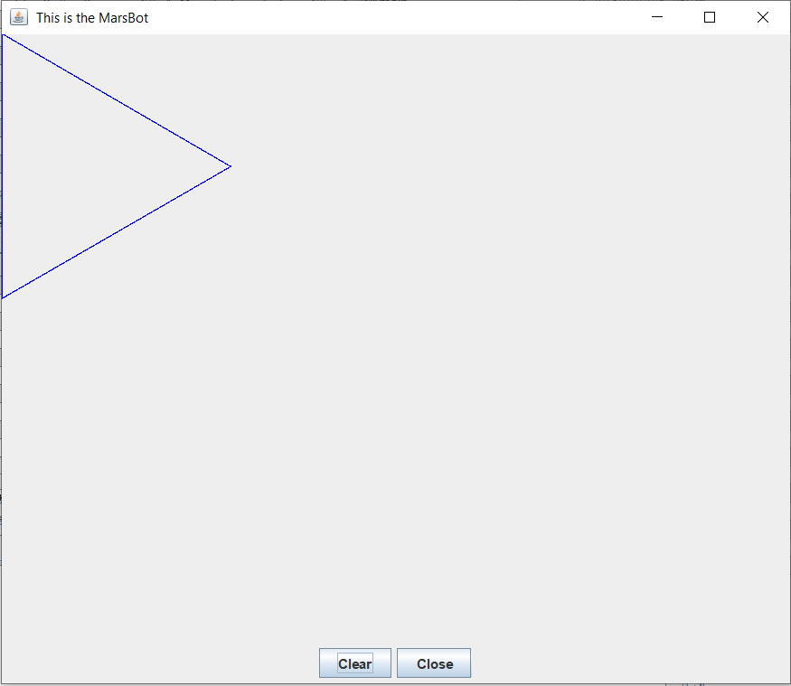

Assignment 4:

Code:

.eqv KEY_CODE 0xFFFF0004 # ASCII code from keyboard, 1 byte

.eqv KEY_READY 0xFFFF0000 # =1 if has a new keycode ?

# Auto clear after lw

.eqv DISPLAY_CODE 0xFFFF000C # ASCII code to show, 1 byte

.eqv DISPLAY_READY 0xFFFF0008 # =1 if the display has already to do

# Auto clear after sw

.eqv e_Char 0x65

.eqv x_Char 0x78

.eqv i_Char 0x69

.eqv t_Char 0x74

.text

li $k0, KEY_CODE

li $k1, KEY_READY

li $s0, DISPLAY_CODE

li $s1, DISPLAY_READY

loop: nop

WaitForKey: lw $t1, 0($k1) # $t1 = [$k1] = KEY_READY

beq $t1, $zero, WaitForKey # if $t1 == 0 then Polling

ReadKey: lw $t0, 0($k0) # $t0 = [$k0] = KEY_CODE

j checkE

WaitForDis: lw $t2, 0($s1) # $t2 = [$s1] = DISPLAY_READY

beq $t2, $zero, WaitForDis # if $t2 == 0 then Polling

ShowKey: sw $t0, 0($s0) # show key

nop

j loop

checkE: beq $t3, e_Char, checkX # check if exist e in queue, checkX

bne $t0, e_Char, WaitForDis # if current char is not e, continue

add $t3, $t0, $zero # save 'e' to $t3

j WaitForDis

checkX: beq $t4, x_Char, checkI # check if exist x in queue, checkI

bne $t0, x_Char, reset # if current char is not x, reset then continue

add $t4, $t0, $zero # save 'x' to $t4

j WaitForDis

checkI: beq $t5, i_Char, checkT # check if exist i in queue, checkT

bne $t0, i_Char, reset # if current char is not i, reset then continue

add $t5, $t0, $zero # save 'i' to $t5

j WaitForDis

checkT: beq $t0, t_Char, terminate # check if meet t, terminate (exit word complete)

j reset # if current char is not t, reset then continue

reset: li $t3, 0 # set 'e' to unspecified

li $t4, 0 # set 'x' to unspecified

li $t5, 0 # set 'i' to unspecified

j WaitForDis

terminate: li $v0, 10

syscall

Ban đầu:

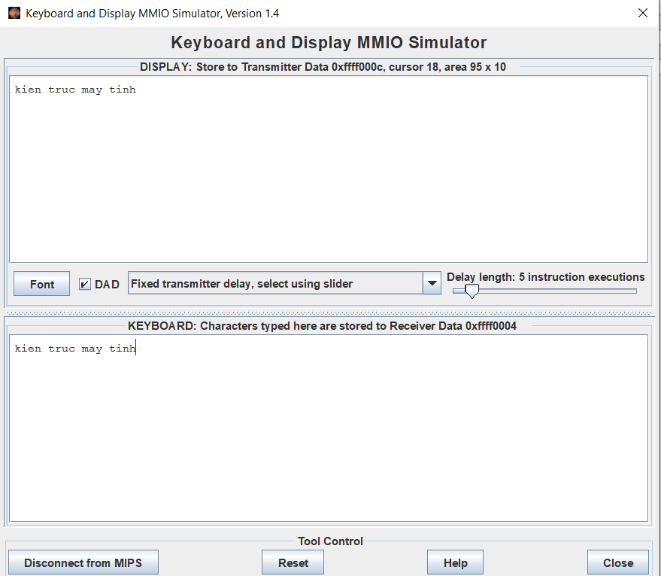

Sau khi exit:

